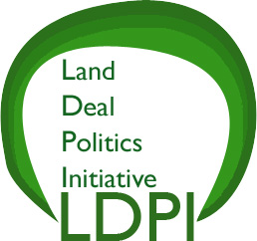
www.iss.nl/ldpi

The Land Deal Politics Initiative

CALL FOR PAPERS

International Academic Conference

GLOBAL LAND GRABBING II

October 17 – 19, 2012
Cornell University, Ithaca, New York

The Land Deal Politics Initiative (LDPI) is organizing a second international academic workshop on ‘Global Land Grabbing’ to be held on 17-19 October 2012 at the Africana Studies Center at Cornell University, Ithaca, NY, USA. The event will be co-organized and hosted by the Department of Development Sociology. Among the confirmed keynote speakers is the new Director-General of the UN Food and Agriculture Organization (FAO) and Brazilian academic, José Graziano da Silva.

This conference is a follow up to the highly successful 2011 conference held 4-6 April at the Institute for Development Studies at the University of Sussex, Brighton, England (www.future-agricultures.org/land-grab.html). At that conference, 120 papers were presented that sketched the broad outlines of land grabs happening across the globe. A convergence of factors has been driving a revaluation of land by powerful economic and political actors. This is occurring across the world, but especially in the global South. As a result, we are seeing a dramatic rise in the extent of cross-border, transnational corporation-driven and foreign government-driven, large-scale land deals unfolding worldwide. The phrase ‘global land grab’ has become a catch-all phrase to describe this explosion of (trans)national commercial and government-driven land transactions revolving around the production and sale of food and biofuels, conservation and mining activities.

The purpose of the 2012 conference is to continue deepening and broadening our understanding of global land deals. As before, we remain open to broader topics around land grab intersections with political economy, political ecology and political sociology, and will convene a series of parallel sessions on a range of themes responding to the issues below (and others):

- Agrarian Change: What changes in broad agrarian structures are emerging? Are land deals motivated by new forms of agrarian capitalism or repeats of the past? What is the nature and extent of rural social differentiation – in terms of class, gender, ethnicity – following changes in land use and land property relations as well as organizations of production and exchange?
- Power and Politics: What are the emerging trends around dynamics of power, elites and corruption; land as a source of patronage? How can we make sense of the politics of land deals in different contexts? What are the dynamics of international politics of land grabs in the broader context of energy, mining, forestry and conservation; and the role of big capital and powerful interests?
- Finance: How are land deal contracts developed between foreign and local companies and national states and financiers? Who finances these deals? What is the role of sovereign funds, hedge funds, pension funds and other financial instrument? Who is involved? How does the money flow? How and to what extent has (trans)national finance speculation played a role in land deals in the context of the convergence of food, fuels, climate and finance crises?
- Policy Narratives: What are the various competing policy and political narratives and discourses around the multiple crises of food, energy, climate and finance, and how have these shaped and been reshaped by the land deal politics? What narratives exist around ‘investment, growth and modernization’ versus ‘marginalization, displacement and impoverishment’, and so on? How do global narratives of ‘scarcity’ drive land investments? How is scarcity constructed in a global political economy of the land rush? How do these narratives differ between key investors and investments?
- Institutional Forms and Business Models: How do different institutional arrangements – and the associated business models for such investments, ranging from estate models to contract farming - influence livelihoods, labour, resource use and agrarian transformation?
- Green Grabbing: What environmental rationales are being deployed to appropriate land and nature? How does nature conservation, carbon sequestration, ecosystem service valuation intersect with land grabbing?
- Land, Tenure and Property: How have competing frameworks and views on land property been deployed by various camps around the contested meanings of ‘marginal lands’ (or, idle’, ‘waste’, ‘unoccupied’ lands)? How is a new dynamic of ‘enclosure’ operating? What assumptions about property rights, tenure and land access are being deployed?
- Displacement and Dispossession: Have development-induced displacement and dispossession occurred? How and to what extent and with what immediate and long-term outcomes and implications for rural livelihoods, including new rural refugees or internally displaced peoples (IDPs)?
- Alternatives: What are some of the relevant emerging alternatives from key actors? Are some of the traditional policies such as land reform, and some of the more recent alternative visions such as ‘food sovereignty’ (and ‘land sovereignty’) relevant and useful in protecting and promoting the interest of the rural poor in the midst of these (trans)national commercial land deals?
- Resistance: What is the range of reactions from local communities to these investments? To what extent have agrarian political struggles been provoked by the new land investment dynamics? What are the issues that unite or divide the rural poor, organized movements, and rural communities around the issue of land deals?
- International Policy Actors: Have global land policies of different overseas development agencies (World Bank, FAO, EU, IFAD, and so on) contributed to facilitating/encouraging or blocking/discouraging land deals? What are the limitations of ‘code of conduct’, certification, regulation, information dissemination, and capacity-building strategies?

The organizers invite papers that offer rigorous and innovative analysis of this list of issues. Papers based on recent, original field research are especially welcomed. We also encourage comparative studies. We welcome proposals for thematic panels. Doctoral students and younger researchers, particularly from the global South, are especially encouraged to participate.

Instructions for submission of paper abstracts (250 words)

The deadline for the Call for Papers is 31 May.

Please submit abstracts and requests for additional information to: landpolitics@gmail.com

For thematic panel proposals, please submit a page long argument of why the panel is relevant and important. Proposed papers for the panel will be reviewed in the same manner as individual abstracts.

For paper abstracts, include your full contact details (email, tel/fax) as well as your institutional affiliation.
Some papers presented at the workshop will be selected and considered for publication in The Journal of Peasant Studies, which is SSCI ranked, and possibly other journals. For more information about the journal and to request a free sample copy go to: www.tandf.co.uk/journals/jps

Travel grants
We have a very modest fund for travel grants for successful applicants coming from universities/research institutions located in the Global South. For the rest, we will be unable to provide travel grants. But we will be able to provide free lunches and snacks at the conference for all conference participants. At a later date, we will provide information about various options on affordable student rate hostels in Ithaca.

The LDPI was established by a group of five: Jun Borras, with the Initiatives in Critical Agrarian Studies (ICAS) of the International Institute of Social Studies (ISS) in the Hague (Netherlands); Ian Scoones, with the Future Agricultures Consortium whose Secretariat is based at the Institute of Development Studies (IDS), University of Sussex (UK); Ruth Hall, with the Institute for Poverty, Land and Agrarian Studies (PLAAS) of the University of the Western Cape (South Africa); Ben White, with The Resources, Environments and Livelihoods (RELIVE) cluster at the International Institute of Social Studies (ISS) in the Hague (Netherlands); and Wendy Wolford, with the Polson Institute of Global Development of Cornell University (USA).

Coordinating institutions:
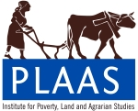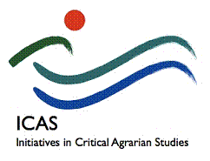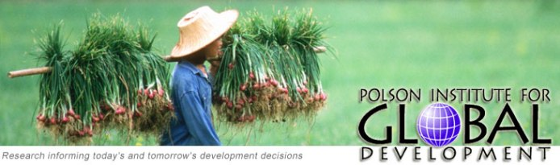

In collaboration with The Journal of Peasant Studies

